UNIT 11. KEEP FIT, STAY HEALTHY
A. A check-up
A1. Listen. Then practice with a partner
* Vocabulary
- medical check-up (n): khám sức khỏe
- medical record (n): phiếu khám sức khỏe
- temperature (n): nhiệt độ
- height (n): chiều cao
- measure (v): đo
- weigh (v): cân, cân nặng

The students of Quang Trung School are having a medical check-up. Hoa, Lan and Nga filled in their medical records and gave them to the nurse. Now they are waiting to see the doctor.

Nurse: Pham Thi Hoa ?
Hoa: Yes
Nurse: Follow me, please. First, I need to take your temperature.
Hoa: OK.
Nurse: Would you open your mouth, please? Thank you. That is 37°C. That's normal. Now I need to know your height. Would you stand here please, so I can measure you?
Hoa: Like this?
Nurse: That's fine. You're one meter 45 centimeters tall.
Hoa: Wow! Last year I was one meter and 30.
Nurse: Now I need to weigh you. Would you get on the scales, please?
Hoa: Oh. I'm 40 kilos.
Nurse: That's good. You can go back to the waiting room now. The doctor will see you in a few minutes.
Hoa: Thank you.
Now answer. Number the sentences.
□ a) The nurse weighed Hoa.
□ b) Hoa returned to the waiting room.
□ c) Hoa left the waiting room.
□ d) The nurse called Hoa’s name.
□ e) The nurse measured Hoa.
□ f) Hoa filled in her medical record.
□ g) The nurse took Hoa's temperature.
□ h) The nurse told Hoa to go back to the waiting room
Anwer key:
5 - a 7 - b 8 - c 2 - d 4 - e 1 - f 3 - g 6 - h
A2. Listen. Then write the missing word.
* Vocabulary
- weight (n): trọng lượng
- heavy (adj): nặng
- male (adj): nam
- female (adj): nữ
Doctor : I want to ……… you a few questions before I start, Hoa. ………. old are you?
Hoa: Fourteen.
Doctor: And ……….. height is one meter ……….. centimeters?
Hoa: No. I think I’m…………….The nurse measured ………….. ______.
Doctor: Oh. How ………….are you?
Hoa: One………..45 ………….. .
Doctor: I …………. ask the …….. to check your ………. again. How heavy are you?
Hoa: I ………. I’m 42 kilos.
Doctor: ………. It says on your ……….. that you’re 40 kilos.
Answer key: ask, How, your, 50, shorter, me, tall, meter, centimeters, will, nurse, height, think, No, form
A3. Ask and answer questions with a partner.
One of you is A and the other is B. Look at the copy of the medical record and cover the other copy. Fill in the missing information.

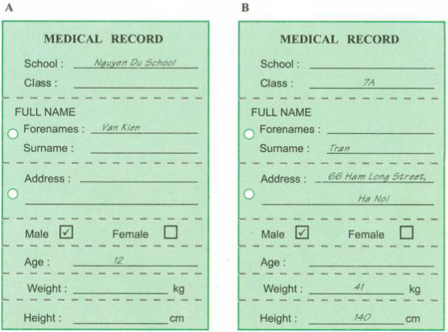
1. Which school does he go to?
- He goes to Nguyen Du school.
2. What class is he in?
- He's in class 7A.
3. What's his surname?
- His surname is Tran.

4. What’s his forename?
- They're Van Kien.
5. What’s his address?
- It’s 66 Ham Long street, Ha Noi.
6. How old is he?
- He's 12.
7. What's his weight?
- He weighs 41 kilos.
8. How tall is he?
- He’s one meter 40 centimeters tall.
B. What was wrong with you?
B1. Listen. Then practice with a partner.
* Vocabulary
- (to) have a bad cold: bị cảm nặng
- (to) have a headache : bị đau đầu
- (to) have a virus: bị nhiễm vi rút
- (to) have a stomachache: bị đau dạ dày
- sick note (n): giấy xin phép nghỉ ốm

Mr. Tan: Where were you yesterday, Lan? You didn't come to school.
Lan: I had a bad cold. I had a headache, too.
Mr. Tan: Oh dear! You were sick. How do you feel now?
Lan: I feel OK, but I'm a little tired.
Mr. Tan: Oh, you should stay inside at recess. The weather's awful today. Did your Mom write a sick note for you?
Lan: No, she didn't. But I have this note from the doctor.
Mr. Tan: I'll be fine. Oh, I see. You had a virus. I hope you will be OK.
Lan: Thank you.
Now answer.

a) Why didn't Lan go to school yesterday?
b) What was wrong with her?
c) What does Mr. Tan tell Lan to do?
d) What did the doctor say about Lan's problem?
e) Who wrote Lan's sick note?
Answer key:
a. Because she was sick.
b. She had a bad cold and a headache, too.
c. He suggested that Lan should stay in class in recess.
d. He said Lan had a virus.
e. The doctor wrote Lan's sick note.
2. Take a survey. Draw this table in your exercise book.

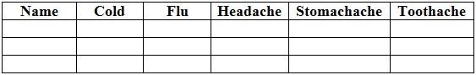

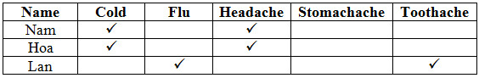
Then ask three friends these questions and check the table.
You: Were you ever absent from school last semester?

Nam: Yes, I was.
You: Were you sick?
Nam: Yes. I was.
You: Did you have a cold?
Nam: Yes, I did. I also had a terrible headache.

B3. Listen. Then complete the table.
Days lost through sickness in class 7 A last semester

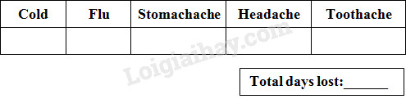

Tapescript:

Last semester in class 7A, there was a total of 112 days' absence due to sickness.
The total breaks down as follows: most absences- 43 -were due to flu.
Then came stomach problems with 37.
Toothache came next with 17.
Colds accounted for 10 absences.
Finally, headaches caused 5 days’ absence.

Answer key:

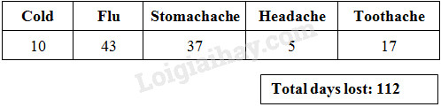

B4. Read. Then answer the questions.
- disease (n): bệnh tật
- symptom (n): triệu chứng
- runny nose (n): chảy nước mũi
- slight fever (n): sốt nhẹ
- cough (v): ho
- sneeze (v): hắt xì hơi
- cure (v): chữa trị
Questions.
a) Why do we call the cold common'?
b) What are the symptoms of the common cold?
c) Is there a cure for the common cold?
d) Do cold cures work? What do they do?
e) How can you help prevent a cold?
Answer key:
a. Because every year millions of people catch it.
b. They’re running nose, a slight fever, coughing and sneezing.
c. No, there isn’t.
d. Not, they don’t. They only relieve the symptoms.
e. We should eat well, do exercise.
Homework: Learn by heart all new words
Prepare for Unit 12.

